

**LAPORAN PRAKTIKUM**

* **Identitas Praktikum**

Nama MK : Struktur Data

Kode MK : CCK2AAB4

Bobot SKS : 4 SKS

Tempat : L-Program, Gedung DC, lantai 3

Hari, tanggal : Selasa, 24 September 2024

Jam : 12:30-14:30 WIB

Topik praktikum : Modul-1 Code Blocks IDE & Pengenalan Bahasa C++

(Bagian Pertama)

* **Identitas Mahasiswa**

Nama lengkap : Afad Fath Musyarof Halim

NIM : 2211104030

Program Studi : Software Engineering

* **Hasil Praktikum** 
  1. Code Blocks
     1. Instalasi

* + 1. Membuat Project
       1. File > New > Project

* + - 1. Console App > Go

* + - 1. Pilih C++

* + - 1. Isi text field

* + - 1. Kondisi Default

* + - 1. Project selesai dibuat

* + - 1. Untuk menjalankan gunakan tombol Build lalu Run

* 1. C++  
     C++ adalah bahasa pemrograman yang di sempurnakan yang berasal dari bahasa pemrograman C.
  2. Struktur Dasar
     1. Variable (berubah)  
        A screenshot of a computer program

        Description automatically generated  
        A screen shot of a computer

        Description automatically generated
     2. Konstanta (Tetap)
        1. Berhasil

* + - 1. Jika dicoba untuk dirubah maka error

* 1. Input / Output
     1. Output (cout)   
        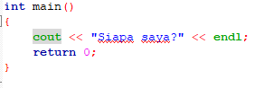  
        A screenshot of a computer

        Description automatically generated
     2. Input (cin)  
        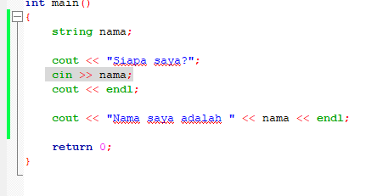  
        A screenshot of a computer

        Description automatically generated 🡺 A screenshot of a computer

        Description automatically generated
  2. Operator  
     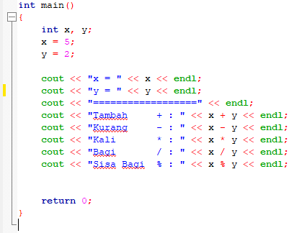  
     A screenshot of a computer program

     Description automatically generated
  3. Pemodifikasi
     1. Unsigned (Jika hanya nilai positif)
     2. Short (Angka yang kecil)
     3. Long (Angka yang besar)
  4. Kondisional
     1. If-Else  
        A computer code with colorful text

        Description automatically generated  
        A screenshot of a computer program

        Description automatically generatedA screenshot of a computer

        Description automatically generated  
        A screenshot of a computer

        Description automatically generated
     2. Switch-Case

* 1. Perulangan
     1. For-While
        1. Bentuk For  
           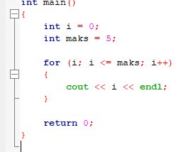
        2. Bentuk While  
           A screenshot of a computer code

           Description automatically generated
        3. Hasil  
           A screen shot of a computer

           Description automatically generated
     2. Do-While  
        A computer code with colorful text

        Description automatically generated  
        A screenshot of a computer

        Description automatically generated
  2. Struktur  
     Aturan dalam codingan (Type nama_variable, dll)
  3. Blok kode  
     Tiap baris kode
* **Latihan**

1. Buat program:
   1. Menerima input 2 bilangan float
   2. Berikan hasil output penjumlahan, pengurangan, perkalian, dan pembagian dari 2 bilangan tersebut

-Coding

-Running

* Pembahasan
  + Insisiasi variable
  + Input variable dari user
  + Hitung dan output hasil

1. Buat program:
   1. Input angka (dari 0 – 100)
   2. Berikan output angka dalam bentuk tulisan

-Coding

-Running

* Pembahasan
  + Inisiasi variable dan input user
  + Menentukan bilangan puluhan
  + Mengurangi sampai tersisa satuan
  + Menentukan bilangan satuan sampai 19
  + Cek apakah inputan 0
  + Tampilkan hasil

1. Buat Program:

* Coding  
  A screenshot of a computer program

  Description automatically generated
* Runing  
  A screenshot of a computer

  Description automatically generated
* Pembahasan
  + Input a
  + Perulangan Iterasi dari a ke n
  + Perulangan untuk posisi spasi dari kiri
  + Tampilkan angka dari kiri yang terbesar
  + Berikan asterisk / bintang
  + Tampilkan angka dari kiri yang terbesar